Tab 3
cHi, Figma link here:
Figma
Use Excel to graph, make sure your fonts are Inter
Duy:
- Key Economic Metrics:
- GDP Growth: Vietnam’s Economy showed a strong economic momentum with the real GDP in Q2/2025 reached 7.96%, exceeding the expansion expectation of 6.9% last quarter and 7.25% from last year.
- Inflation: The average CPI in Q1, 2025 rose 3.2% Y-o-Y, well within the government target range of 3.0-4.5%
- Registered FDI: Registered FDI reached $28.54 Bn for the first 9 months of 2025, reflecting a 15.2% increase compared to the same period last year.
Vietnam Real Estate Market 2025: A Cautious Recovery Amid Renewed Optimism
After a turbulent period from 2022 to 2024, Vietnam’s real estate market in 2025 is entering a cautious yet hopeful phase, characterized by selective investment, improving fundamentals, and early signs of stabilization. While prices have not yet fully rebounded to 2022 peaks, steady recovery is visible in key segments, particularly housing and industrial real estate, supported by favorable macro conditions and renewed investor confidence.
Market Overview 2025: From Correction to Consolidation
Traditionally, Vietnam’s property market thrives between mid-September and January, but 2025 has seen an irregular cycle. Following a deep correction during 2022 to 2024, the market is now stabilizing with uneven recovery across segments and regions.
Short-term forecasts suggest a largely flat market through year-end, with price increases expected only in select areas boasting strong development potential and reasonable pricing. Hanoi shows moderate growth potential, mainly in southern and southwestern districts, while Da Nang has already experienced steep price surges, limiting further short-term upside. Smaller localities such as Can Gio and Phu Quoc offer brighter prospects for medium-term capital appreciation, supported by infrastructure development and tourism revival.
According to Savills Vietnam, the apartment segment in Hanoi recorded over 22 percent price growth year-on-year in late 2024, driven by renewed supply and improved legal transparency. Meanwhile, Ho Chi Minh City’s market is entering a consolidation phase, with transaction volumes slowly picking up after years of stagnation.
(Duy)
Sources:
- https://www.globalpropertyguide.com/asia/vietnam/price-history#_Demand_Highlights
- https://content.knightfrank.com/research/3020/documents/en/vietnam-real-estate-market-quarterly-market-highlights-q2-2025-12281.pdf?_gl=1*j1h8zv*_ga*MTMwNjM1OTMzMC4xNzYwNzMwOTg5*_ga_K723LXJ440*czE3NjA3MzA5ODckbzEkZzEkdDE3NjA3MzA5ODkkajU4JGwwJGgw
- https://journeys.jll.com/share/UJAToRCOOACbz8LEvJtw3YNsiSQe7VLaJq93rXsRetdBE2yvP8r0v5H0d31dD%252fEH
- https://www.vietnam-briefing.com/news/vietnam-real-estate-market-2025-prime-investment-destination-southeast-asia.html/
- https://www.avisonyoung.com/news-releases/-/aynp/view/2025/04/15/avison-young-vietnam-releases-quarterly-report-of-vietnam-real-estate-quarter-i-2025/in/vietnam
Residential Apartment Demand Recap
- Hanoi:
According to data from JLL Vietnam, the average selling price of apartments in Hanoi reached USD 2,865 per square meter (sqm) in Q1 2025, representing a 29.6% year-on-year (YoY) increase. On a quarter-on-quarter (QoQ) basis, prices remained relatively stable, indicating a temporary plateau following previous upward momentum.
On a year-to-year basis, Hanoi witnessed a strong growth in the demand for apartments with a 49% YoY surge to 7,914 units in Q1 2025 (Savills). Yet, the QoQ change marked a 41% decrease in sales showing a slow and cautious vision from investors. The same trend pattern can be similarly seen from the Villas and Townhouses sector where sales transactions rose strongly YoY to reach 1,629 units in Q1 2025, yet the QoQ declined by 49%.
Despite the recent quarter-on-quarter contraction in sales volume, investor sentiment toward Hanoi’s real estate market remains broadly optimistic. This confidence is underpinned by key legislative reforms, particularly the 2024 revisions to the Land Law, Housing Law, and Real Estate Business Law. These legal updates are expected to enhance transparency, streamline development procedures, and stimulate both ongoing and future real estate projects across the capital.
What are some areas that are seeing new developments in Hanoi? Check Knight Frank’s pdf. Why are those areas experiencing that uptick? Draw a map and embed it here. Name a few notable developments, open up the news and see if there's anything happening to it.

- Ho Chi Minh City
Compared to Hanoi, Ho Chi Minh City’s real estate market demonstrated a more stable yet subdued growth trajectory in Q1 2025. Apartment prices in HCMC recorded a modest year-on-year (YoY) increase of 1.5%, reaching an average of USD 3,316 per square meter. This marginal growth continues a trend of restrained price movement, following a 1.4% YoY increase in Q4 2024, and declines of 2.5% and 1.5% in Q3 and Q2 2024, respectively.
The tempered pace of price appreciation is primarily attributed to weakened consumer demand. Apartment sales fell sharply by 46% quarter-on-quarter (QoQ) in Q1 2025, totaling just over 1,400 units sold. Despite this short-term decline, the market still posted improved performance on a YoY basis, reflecting the early signs of stabilization amid ongoing structural and regulatory reforms.
⇒ Outlook: HCMC is also forecasted to be on a brink of a breakthrough with positive expectations from analysts and investors attributed to the efforts of HCM’s People’s committee to resolute key legal challenges for capstones real estate projects as well as the promising final-phase development of upcoming projects anticipated to be driving market’s demand including Eaton Park (Gamuda Land), Global City (Masterise), and Vinhomes Grand Park Opus One (Samty & Vingroup). (JLL Vietnam, 2025)
Again, include some more fundamentals charts (see cushman wakefield and knight frank) what areas in hcmc? Draw a map, and talk about the why? Potential reason for price increases or new developments can be Long thanh airport or upcoming metro routes
Average Price/M^2, Unit Size & Apartment Price Data
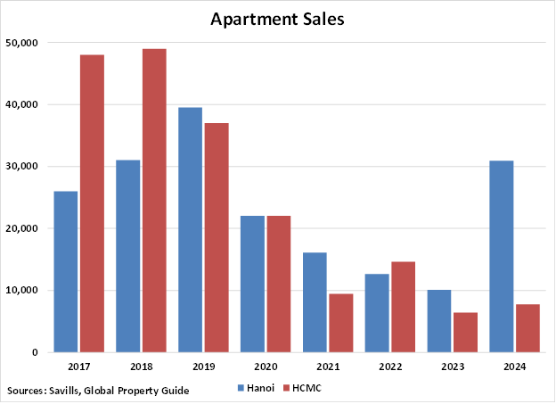
Figure: Total apartment sales in Hanoi and HCMC 2017-2024
Investor Sentiment and Capital Flow: From Speculation to Strategy
Investor behavior has shifted dramatically since the speculative boom years. The short-term flipping mindset that dominated earlier cycles has largely faded, replaced by strategic, long-term investment approaches.
Three major factors underpin today’s more balanced sentiment:
- Resolved legal bottlenecks: Many long-delayed projects have resumed after key reforms under the new Land Law (2024) and Housing Law (2025), unlocking supply in major cities.
- Easing capital constraints: Lower interest rates, accessible credit, and stable bad debt levels have restored liquidity, allowing developers to refinance and launch new projects.
- Renewed investor confidence: Domestic macroeconomic stability and improving governance have drawn both domestic and foreign investors back to the market.
However, capital flows remain selective. Many local investors are temporarily reallocating to stocks, gold, and digital assets, while foreign institutional investors continue targeting industrial, logistics, and affordable housing projects that offer steady yields and long-term value.
Structural Drivers and Sectoral Outlook
Residential Segment
Vietnam’s housing market is slowly entering its next growth phase from 2025 to 2027, fueled by a combination of low interest rates, increased supply, and supportive government policy. Social housing is a standout, with developers and policymakers prioritizing affordability and livability.
The market is evolving from a land plot dominated investment pattern to a diversified rotation across land, resort properties, and condominiums, depending on location and market cycle. Buyer preferences are shifting toward mid-tier and affordable housing, where end-user demand remains strong. Luxury oversupply, especially in Ho Chi Minh City, continues to pressure prices.
Industrial and Logistics
This sector remains the brightest spot in Vietnam’s real estate landscape.
According to the annual report from Cushman & Wakefield, momentum industrial index which recorded industrial and logistics measures of over 120 countries, Vietnam’s industrial warehouse rent has jumped over 70% in the past 6 years with the last year alone rising 7%. This rapid logistics growth can be attributed for the variety of factors:
- Mass inflows of foreign investment (FDI): Due to geo-political instability across the world and a rising manufacturing cost in China, manufacturers have been seeking for a more affordable alternative option for factory placement. Vietnam has been a beneficiary of this trend, receiving a steady FDI inflows of over 25 billion US dollars with a y-o-y growth rate of 9.4% in 2024 are driving demand for modern industrial parks and logistics hubs.
- Competitive warehouse rent cost: The average cost of Warehouse in Vietnam remains below $5 per sqm per month, making it competitive against other major warehouse hubs including India, Thailand and Nigeria.
- Low labour cost: The average labour cost in Vietnam is ~25% lower than the global average, making Vietnam one of the most labour cost-effective countries in the whole Asia-Pacific division.
High occupancy rates in key provinces such as Bac Ninh, Binh Duong, Long An, and Hai Phong reflect sustained foreign tenant demand. Developers like Becamex (BCM) and Kinh Bac City (KBC) are well-positioned, with robust project pipelines and expanding land reserves.
Source:
- https://www.tracedataresearch.com/industry-report/vietnam-logistics-and-warehousing-market
-https://content.knightfrank.com/research/3019/documents/en/the-vietnam-investment-guide-2025-12280.pdf
Commercial, Office and Retail
Office markets are showing bifurcation. Premium green-certified Grade A spaces enjoy strong occupancy, while older stock faces obsolescence. The retail segment is pivoting to mixed-use, experiential spaces integrating lifestyle and entertainment, aligning with post-pandemic consumer shifts.
Major Developers and Market Leaders
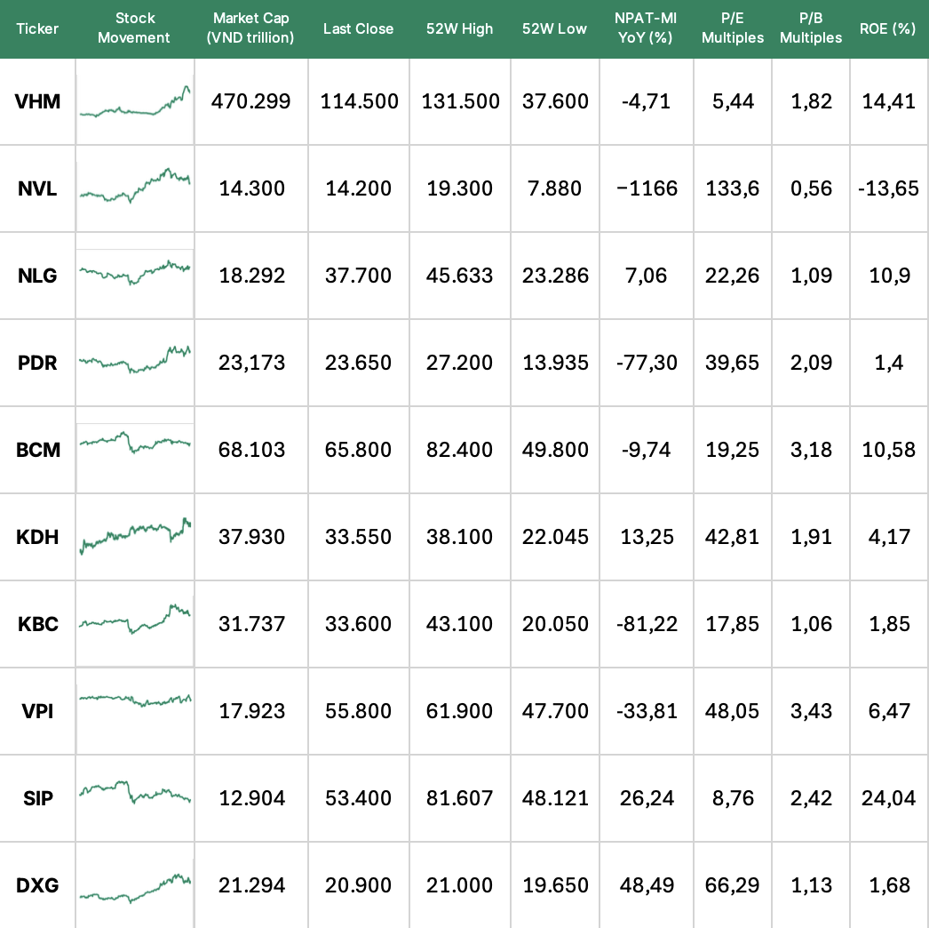Seriosuyl bro
Source: LSEG Workspace, CafeF, Yahoo Finance
Company: Vinhomes (VHM)
- Ticker: HOSE: VHM
- Focus: Urban residential, hospitality, etc
- Remarks: Vietnam’s largest and most reputable developer; continues to benefit from its nationwide urban ecosystem.
Company: Novaland (NVL)
- Ticker: HOSE: NVL
- Focus: Luxury housing and resorts
- Remarks: Recovery play after liquidity stress; strong brand in southern markets.
Company: Nam Long Investment (NLG)
- Ticker: HOSE: NLG
- Focus: Mixed-use mini-city projects
- Remarks: Focused on affordable urban developments targeting middle-class families.
Company: Phat Dat (PDR)
- Ticker: HOSE: PDR
- Focus: Residential and commercial real estate
- Remarks: Known for projects in Ho Chi Minh City; pivoting to new suburban growth areas.
Company: Becamex (BCM)
- Ticker: HOSE: BCM
- Focus: Industrial and logistics
- Remarks: Leader in industrial park development; benefits from FDI inflows.

Company: CapitaLand Vietnam
- Focus: Premium residential and office developments
- Remarks: Singapore-based global developer; significant foreign player in Vietnam’s high-end segment.
Stock Market Insights: Developers Rally Amid Upgrade Buzz
Vietnam’s real estate equities have staged a remarkable rebound in 2025, tracking the broader rally following Vietnam’s FTSE Russell upgrade to Emerging Market status effective 2026. The VN-Index gained over 3 percent in June 2025, buoyed by construction and property-related gains. Real estate stocks, after initial profit-taking, continue to show strong year-to-date growth of 30 to 40 percent for leading tickers such as VHM, NLG, and KBC. Sector P/E ratios vary widely from 5 to 48, reflecting a market divided between undervalued midcaps and growth-driven blue chips. Dividend yields remain modest between 0.6 and 3.4 percent, consistent with reinvestment cycles among developers expanding into new projects.
The Vietnam stock market overall has been on a tear in 2025. According to a macro-market report, Q2 2025 GDP expanded around 8 percent, with construction and real estate project launches contributing meaningfully. The VN-Index posted a 3.1 percent return in June alone. However, the real estate sector index (.VNREAL) faced some short-term profit-taking, declining approximately 1.1 percent in June after earlier strong gains.
Despite this brief consolidation, real estate stocks remain among the top-performing momentum names in Vietnam’s market. On Investing.com’s real estate screener, many developers show double-digit YTD gains of 30 to 40 percent and are categorized as “momentum masters” or “profitable expansions”
Outlook
Looking ahead, the Vietnamese real estate sector is projected to maintain a trajectory of sustainable and stable growth throughout the remainder of 2025, supported by a more transparent legal framework and the growing experiences of market participants.
Real estate remains Vietnam’s most stable long-term asset class despite near-term uncertainty. Prudent investors are advised to:
- Prioritize projects with reputable firms with a proven legal track record, verified housing ownership certificates, prime locations, and access to well-developed infrastructure.
- Avoid over-leverage by keeping borrowing ratios conservative and maintaining liquidity buffers.
- Diversify exposure by combining stable income assets such as industrial parks with capital appreciation plays in urban housing.
- Monitor policy execution, especially around land valuation and foreign ownership reforms.
Short-term opportunities may appear more attractive in equities, gold, or digital assets, but for wealth preservation and inflation hedging, real estate remains Vietnam’s enduring store of value.
Conclusion: A Market in Transition
The Vietnam real estate market in 2025 is in a strategic reset. Developers are focusing on fundamentals, policymakers are strengthening transparency, and investors are rediscovering the market’s long-term potential.
With stabilized financing, supportive regulation, and global capital inflows on the horizon, Vietnam’s property sector is poised for a measured, sustainable expansion through 2027, balancing risk and reward in a maturing market cycle.

Sources
https://www.vietnam-briefing.com/news/vietnam-real-estate-market-2025-prime-investment-destination-southeast-asia.html/ vietnam-briefing.com
https://www.china-briefing.com/china-outbound-news/vietnams-economic-performance-in-h1-2025-inflation-trade-fdi china-briefing.com
https://vietnamnews.vn/economy/1720972/viet-nam-ranks-among-most-cost-competitive-locations-on-global-industrial-map.html vietnamnews.vn
https://vir.com.vn/surge-in-fdi-fuels-growth-of-ready-built-factories-132379.html Vietnam Investment Review - VIR
https://www.globalpropertyguide.com/asia/vietnam/price-history globalpropertyguide.com
- https://www.tracedataresearch.com/industry-report/vietnam-logistics-and-warehousing-market
-https://content.knightfrank.com/research/3019/documents/en/the-vietnam-investment-guide-2025-12280.pdf
- https://www.globalpropertyguide.com/asia/vietnam/price-history#_Demand_Highlights
- https://content.knightfrank.com/research/3020/documents/en/vietnam-real-estate-market-quarterly-market-highlights-q2-2025-12281.pdf?_gl=1*j1h8zv*_ga*MTMwNjM1OTMzMC4xNzYwNzMwOTg5*_ga_K723LXJ440*czE3NjA3MzA5ODckbzEkZzEkdDE3NjA3MzA5ODkkajU4JGwwJGgw
- https://journeys.jll.com/share/UJAToRCOOACbz8LEvJtw3YNsiSQe7VLaJq93rXsRetdBE2yvP8r0v5H0d31dD%252fEH
- https://www.vietnam-briefing.com/news/vietnam-real-estate-market-2025-prime-investment-destination-southeast-asia.html/
- https://www.avisonyoung.com/news-releases/-/aynp/view/2025/04/15/avison-young-vietnam-releases-quarterly-report-of-vietnam-real-estate-quarter-i-2025/in/vietnam

Suggestions
We will use tue’s existing macroeconomic indicators, no need to work more from there i think
1/ We need a few more graphs on the market. Things like: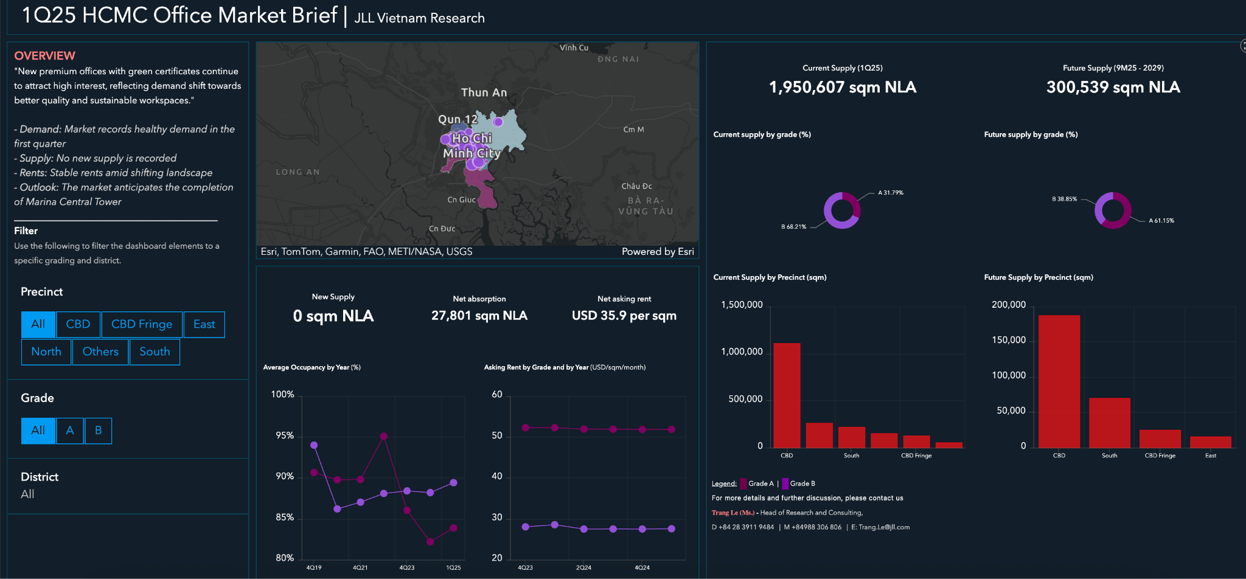

Add a few infographics, as well as from the “fundamentals” section, and separate sections out to office spaces, retail f&b spaces, apartment, hotels, warehouse, factories, etc.
- I think we have to borrow knight frank and jll’s tables and graphs, and change it into our style in excel. These dudes used cbre and cushman wakefield so i think it should clear us to do it too
Talk about updates about existing buildings, talk about new upcoming/recently opened projects
Samples on top of my head in sg:
- Hilton saigon
- A few in thu thiem
- How is Sala doing? How is empire city doing?
- That fuckass building that ha anh tuan bought a penthouse in?
- Anything happening to saigon center’s proposed new building next to it idk
- Any m&a by foreign investors?
2/ What are areas with the most potential for properties? Draw a map around the city and highlight where it has the most potential.
- What is it backed upon?
- How will the new long thanh airport help with anything? How is the new metro construction helping drive up prices in the homes its stations are in?
- What will happen to places like can gio/nha be and its factories upon new fdi? Any news on new stuff being built in the industrial parks?
- Sample below:

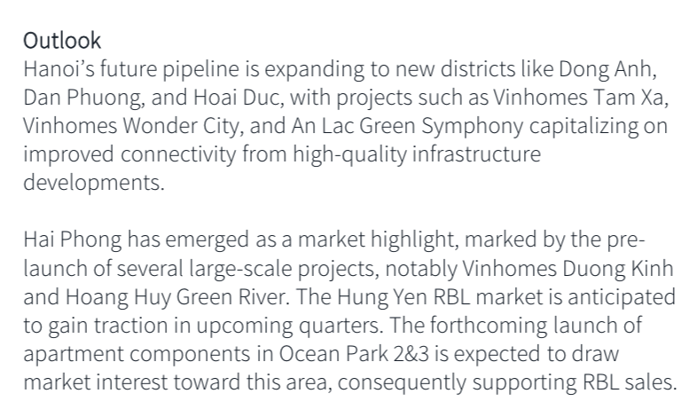

3/ Talk about laws. See whats mentioned on the reports u cited, or the news; Read them, summarize them, see what stands out, write on the report who will benefit
4/ In each region, (hanoi, hcmc, red river delta, mekong delta) talk about:
- Buyer trends? Key players? Is fdi benefitting and where/what segment is it in? landlord/renter’s general broad view on the market?
- 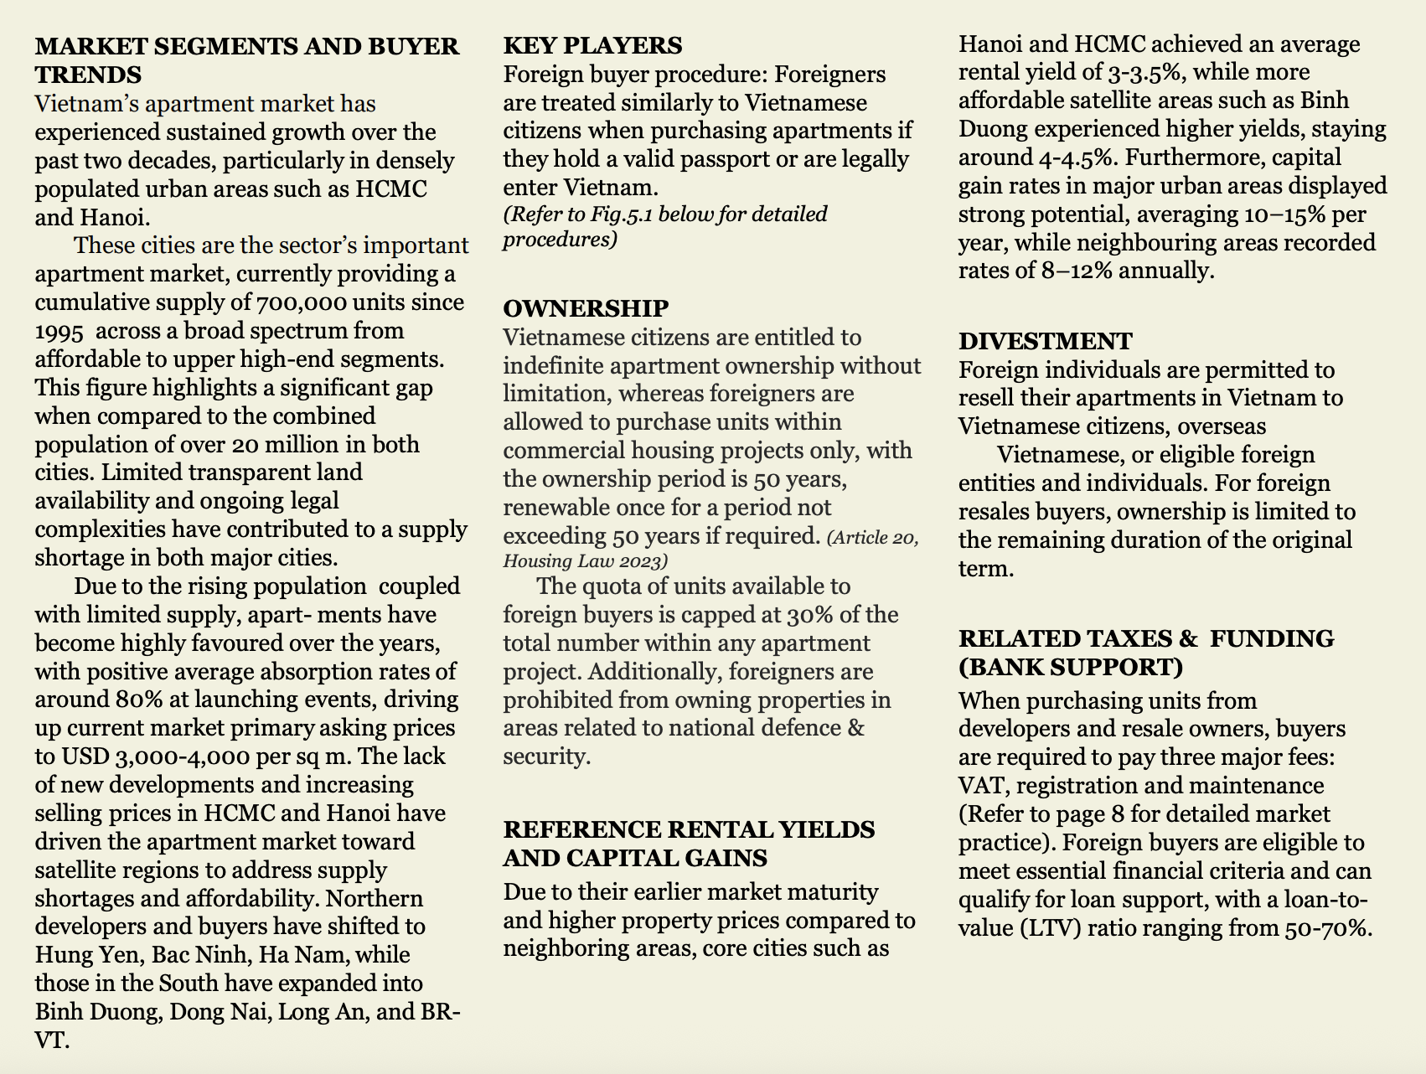
- We unfortunately gotta add a few graphs before we say the words, so updates on office/residential/hospitality/warehouse manufacturing/retail in each region

5/ Talk about the developers themselves. Any news happening to novaland? Becamex? Sun group? Idfk; The goal is to help people who might have bought in the company’s properties or bought equities.
6/ Beware that each company has its own definition of grade a, grade b and grade c offices, take note of that while writing, make your own definition and go a sample of which buildings deserve it
7/ I think the most exciting part for yall should be the new developments, ill link some for inspo
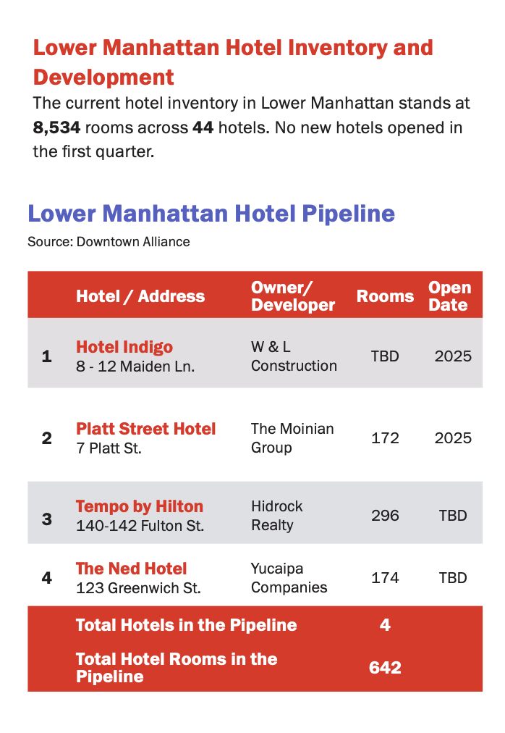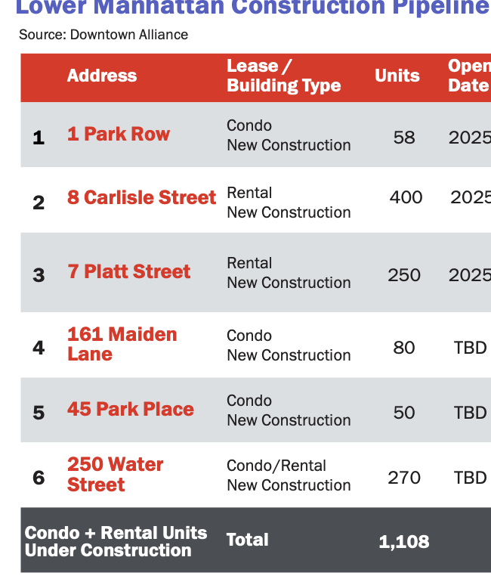

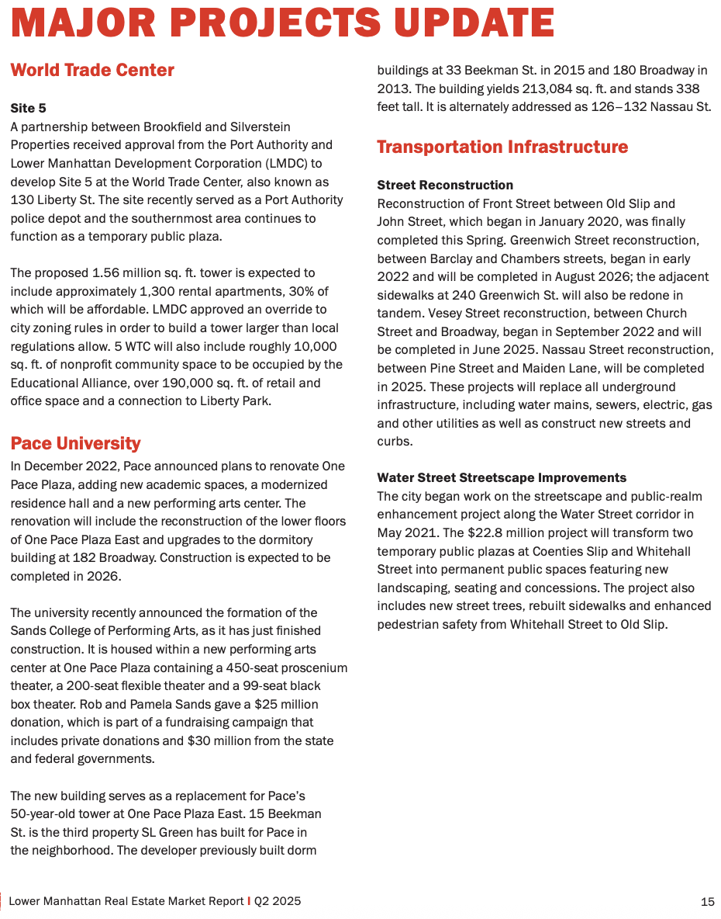
Use these sources
https://assets.cushmanwakefield.com/-/media/cw/marketbeat-pdfs/2025/q2/apac-and-gc/q2-2025-hcmc-marketbeat-en.pdf?rev=6a0a76b16afc4880a7381fed201debc9
https://www.odu.edu/sites/default/files/2024/documents/2024-hampton-roads-real-estate-market-review-forecast.pdf consult this as inspo

https://batdongsan.xaydung.gov.vn/ good data source from GOVT

https://vars.com.vn/nghien-cuu-thi-truong/bao-cao-thi-truong?name=&se_cat=
https://journeys.jll.com/share/UJAToRCOOACbz8LEvJtw3YNsiSQe7VLaJq93rXsRetdBE2yvP8r0v5H0d31dD%252fEH

